Reflections on Shanghai…
Visiting Shanghai has been the greatest honour and privilege of my career so far. Before departing, I knew that I would learn such a lot and come back with fantastic ideas, however, I couldn’t have possibly envisaged the extent of how I would develop both, professionally and personally.
There are many misconceptions around the Chinese Education system; I expected to find perfectly-behaved children, sitting in rows and chanting times tables. This was not the case at all.
Liam and I spent two weeks in two different schools where we observed an abundance of excellent maths lessons. Each was carefully crafted, allowing students to realise the key points of learning for themselves. The teachers took the children through the lessons in small, coherent steps and kept the children moving together through their learning as a class. The lessons were focused and cleverly designed; the children had a deep understanding of mathematics, even in the Grade 1 classes and, as a result, could explain the parts of addition and subtraction calculations using correct mathematical vocabulary such as; addend, sum and minuend.
Children were provided with opportunities to discuss their learning with others and to discover new learning for themselves. The lessons were simple and focused, but the learning was incredible. I was blown away by the calculation skills of such young children and their ability to apply their knowledge to solve real-life problems.
What really struck me, however, was the collaboration amongst the teachers. They worked together, in teacher research groups, to plan lessons with clear, focused key points. Discussions around potential misconceptions and how these would be addressed was a key part of the planning process, as well as detailing what would be on the board to support the children’s learning. Teachers, within the school’s own mathematics department as well as from other schools across the district observed lessons regularly and provided feedback during meetings after the lesson, each teacher acting as the ‘critical friend’ and helping to further improve the lesson. Time was invested in the creation and feedback around these lessons and the professional development of all of the teachers was valued. Lesson planning was an art within its own right and the teachers were specialists, with such deep subject knowledge.
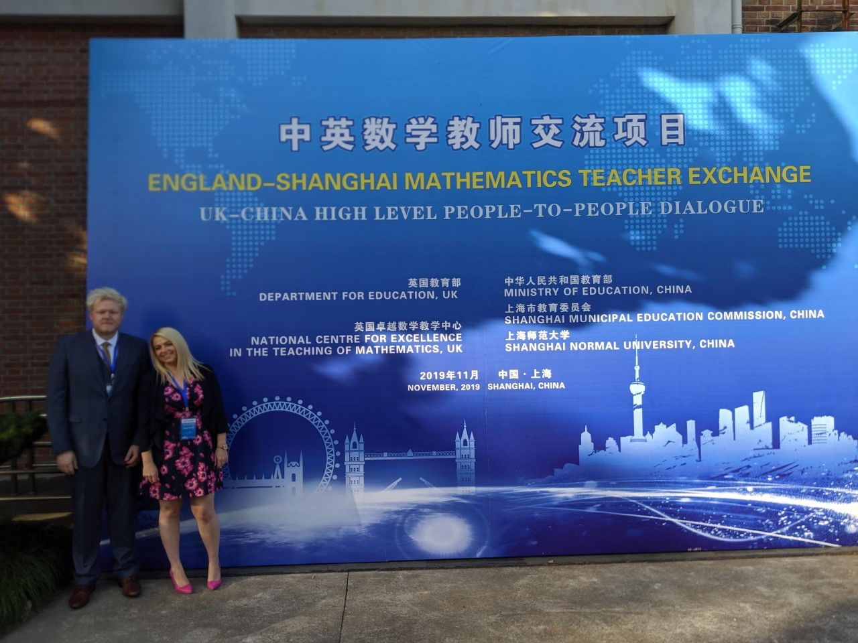
I am eager to share all of the things I have learnt with staff in my own school and with schools that I work with in my Mastery Specialist role. It is an exciting time of change for mathematics teaching and I am both proud and humbled to be a part of it. We are also very much looking forward to welcoming our partner teachers, Miss Qian and Mr Xu to the East Midlands and hope that having the opportunity to see their teaching leaves others inspired, the way we were inspired in Shanghai.

