At the beginning of November I had the privilege of traveling to Shanghai for two weeks to observe teaching for mastery in secondary and primary schools. I can honestly say it was one of the most incredible experiences of my teaching career so far.
It is hard to know where to begin as I was so overwhelmingly impressed by what I saw. Lessons are very carefully crafted and there is a strong sense of collaborative planning within the maths departments I saw. The curriculum has been so carefully designed and honed over a number of years and there isn’t a bulk of content to try and wade through. Lessons are set out in small steps to ensure students are fully confident with the concept being covered. To quote one of my Shanghai partner teachers “Our job in the 40 minute lesson is to make sure students understand the concept, the practice can be done at home”. Students are given 30 minutes of maths homework every day which they all diligently submit the following day. The Shanghai students were incredibly fluent and confident in their maths lessons and could happily move from the concept being taught to producing algebraic generalisations that most of my year 11s would struggle to do.
The curriculum has been set by the government and this is followed explicitly but rather than feeling tied down or restrained it felt liberating, particularly in the current climate of the new Ofsted inspection framework where most heads of maths will be reworking their schemes of work. I saw the same lesson taught by 3 different teachers and each was very different, despite the curriculum being rigidly set and adhered to individual teaching flair and style was in no way encumbered.
What struck me is that it is not just the secondary school maths curriculum that is well sequenced but the whole of it right through from primary. It has made me realise that the transition from KS2 to KS3 still feels disjointed and I fully intend to reach out to my feeder primaries to build stronger links to better support our students.
Observation is a regular part of their teaching ethos. Most of the lessons I observed had numerous members of their own departments sitting in to also observe. The staff then get together after the lesson to discuss teaching approaches which was really refreshing. I also spent time in their TRG’s which take place every Wednesday afternoon with all 200 maths teachers from their district coming together to work together, I found this completely mind-blowing. I am resolved now to ensure the little departmental time I have is spent more productively, focussed on the teaching of mathematics, rather than being distracted by the mundane day to day issues that could be resolved via email.
I could happily continue to discuss my experiences at great length, but do not want to overwhelm the reader. I hope to see some of you at the showcase events in March.
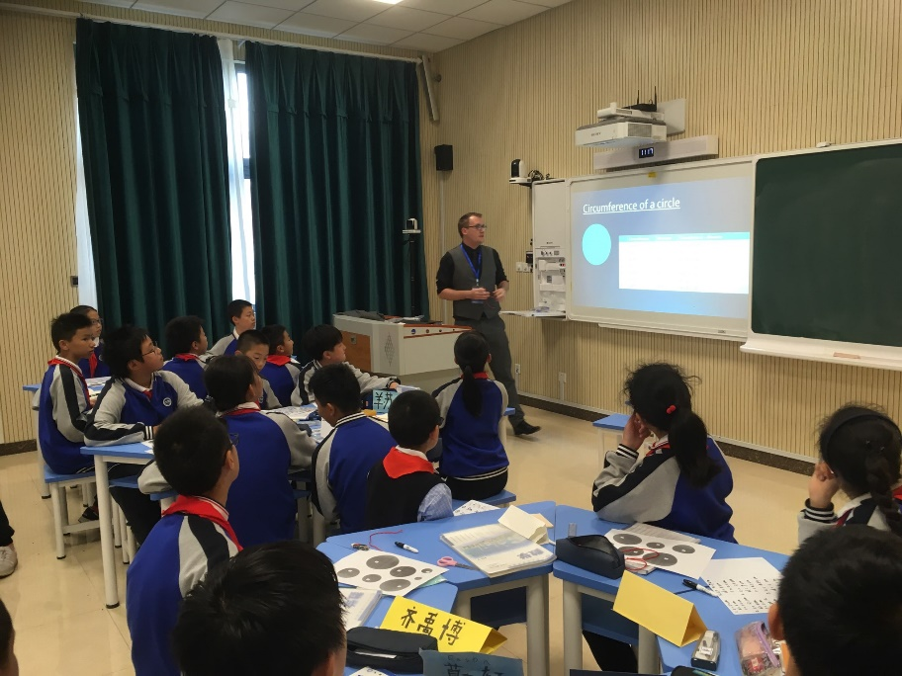
I look forward to hosting our two partner teachers on their visit to the UK in March and am delighted to continue to build the relationships between our schools.

