Reflections from my visit to Shanghai…
I feel extraordinarily grateful to have had the opportunity to visit Shanghai as part of the England-China Mathematics Teacher Exchange. The whole experience, from the moment we landed, was fascinating and I am sure it will remain the greatest piece of professional development I experience in my career.
We were extremely lucky to be able to spend time in two schools and observe some truly amazing lessons taught by some of the best teachers in Shanghai. What I really noticed through speaking to the teachers and observing the daily routine of children and staff is that there is a very clear vision towards every child’s mathematical learning. Every child we spoke to during our trip was positive about learning Maths and enjoyed being able to unpick the rules and laws and really explore the beauty of the Mathematics.
We observed many extremely well crafted lessons which supported this ethos and really challenged student’s (and our!) thinking. The 35-minute lessons were perfectly coherent with lots of small steps to scaffold student’s understanding and contained variation to encourage and deepen their knowledge and allow them to make connections.
From a very early age, it is obvious that all children are exposed to a high level of mathematical vocabulary and dialogue and are encouraged to use it in their reasoning. This is alongside truly exceptional calculation skills and number fluency, which comes from deep practise and procedural variation that is revised and revisited constantly.
Another key finding from our visit, which I knew happened a lot in Asian education systems but didn’t quite appreciate how much until we visited Shanghai, was the amount of collaborative research and lesson design that takes place. Teachers work together almost constantly to refine and craft their lessons, and it is not unusual to have the same amount of adults sat at the back of a classroom observing the learning as there are children in the lesson! This collaborative practise and the feedback that is given to the teacher during the TRG (Teacher Research Group) at the end of the lesson is invaluable to promoting constant improvement. We were fortunate to be a part of the TRGs after every lesson we observed to provide our feedback and make comparisons to our own practise; as well as receiving feedback on lessons we taught to classes of (impeccably behaved!) Shanghai children.
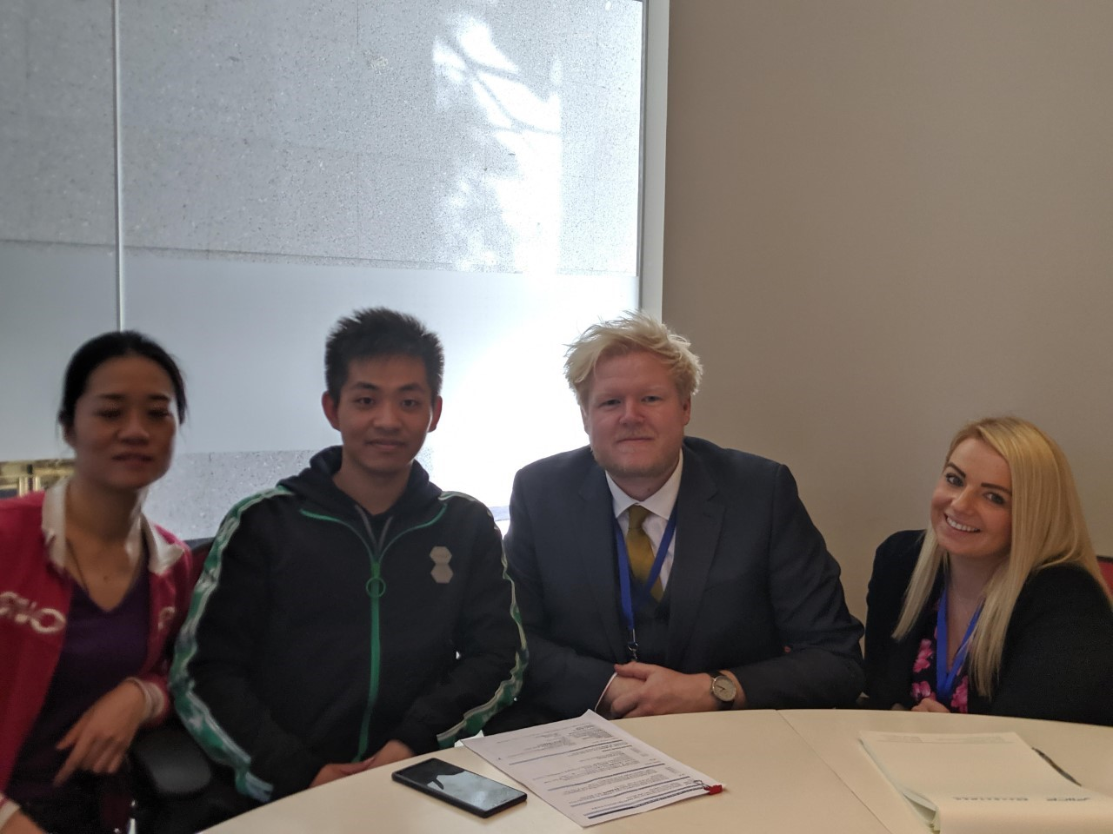
Our Shanghai partner teachers, Ms Qian and Mr Xu delivered some truly outstanding lessons during our time in China and we are so looking forward to hosting them in March. From what we have seen in Shanghai, the showcase lessons at Bardney Primary School promise to be unmissable!

